There are three part in this sample：

1. hwid_server_JAVA_APIdemo.zip，the examples of separate APIs
2. hwid_server_JAVA_Projectdemo.rar，the project of the APIs in spring boot
3. Request.postman_collection.json，the postman’s request of the project

The first part is an example of independent use of the three interfaces；

The second part is to combine various interfaces in a spring boot project. After the project is opened locally, it can be called and run by postman.

The third part is a postman request that calls the sample code project

Request：

Step 1. Call the interfase ‘getCodeUrl’ in the example of project, to get the url request

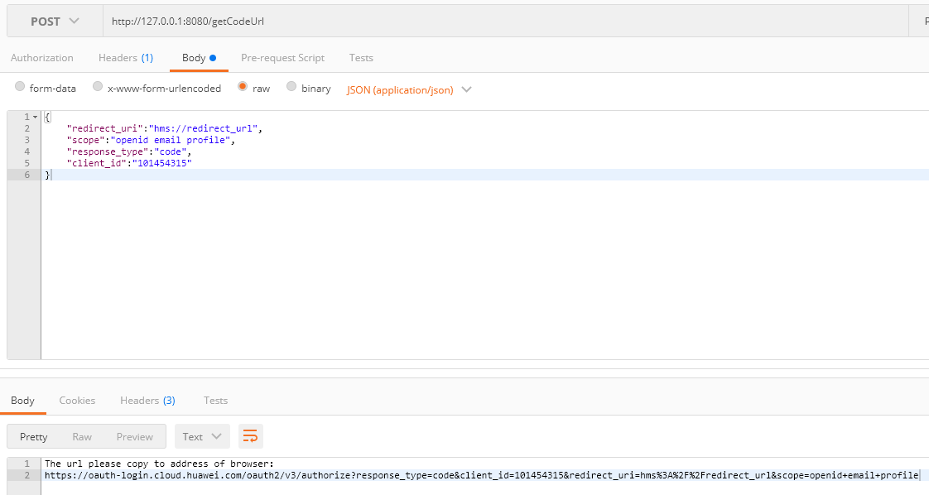

Step 2. Use the url request get in step 1, copy to the browser’s address, login your Huawei account, then click the button ‘Authorize and log in ’

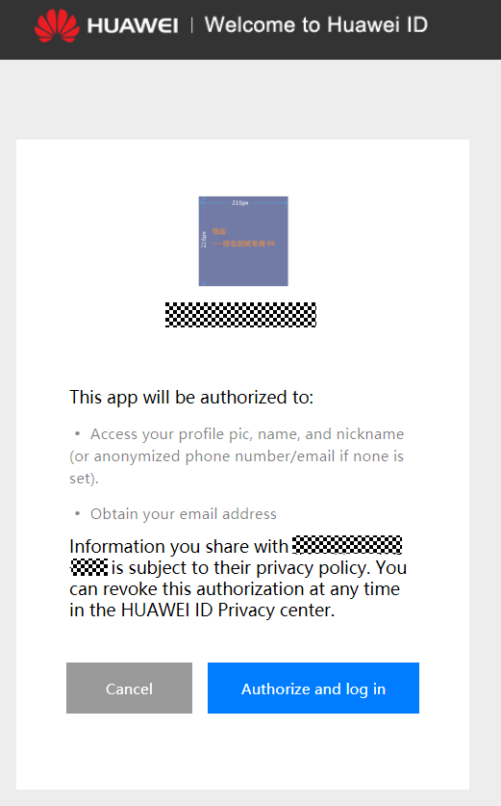

Step 3. After click the button, your can get the code=XXXXXX which can be viewed in the browser through F12(the developer tools)

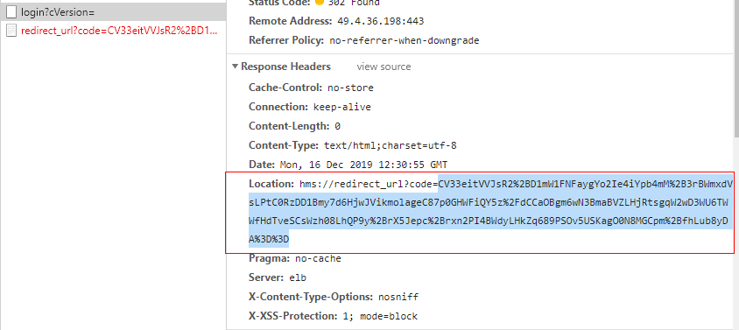

Step 4. Put the code as the input parameter to the interface ‘getTokenByCode’, return access_token

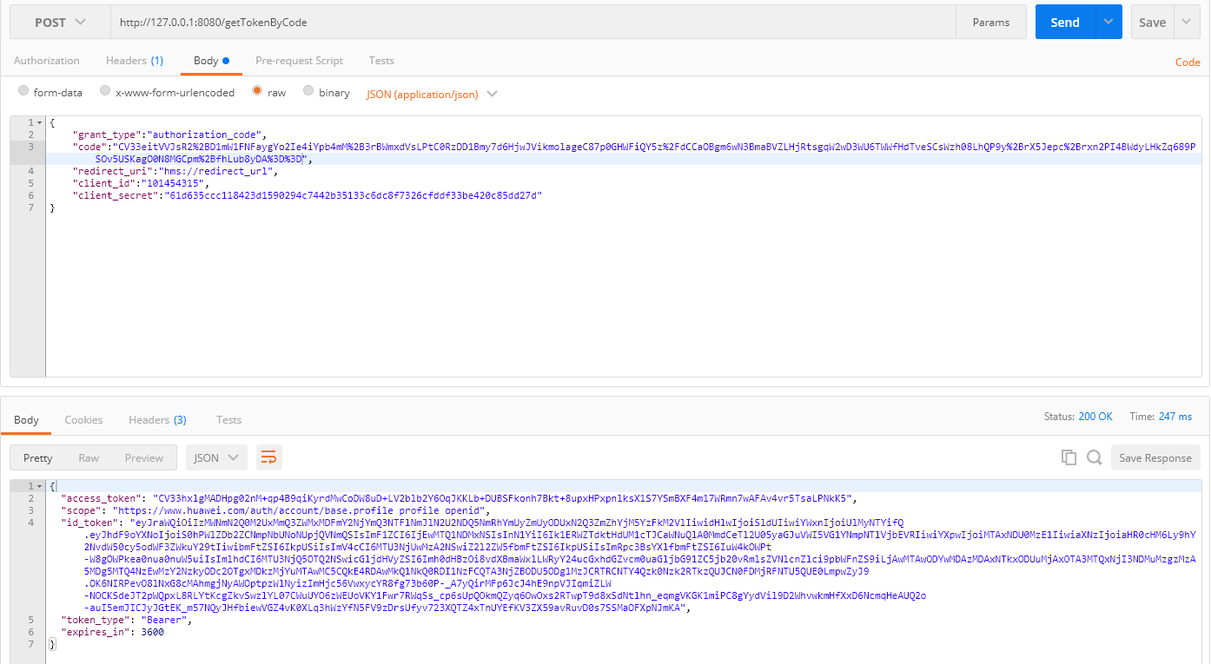

Step 5、Put the access_token as the input parameter to the interface ‘getClientTokenInfo’,return the detail of access_token

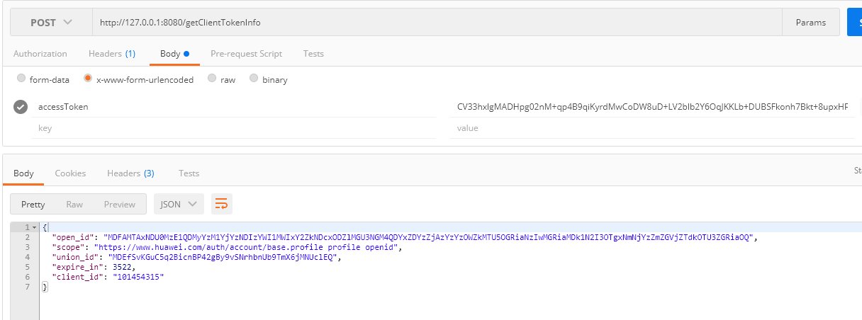

Step 6、Put the id_token as the input parameter to the interface ‘getDetailByIDToken’,return the detail of id_token

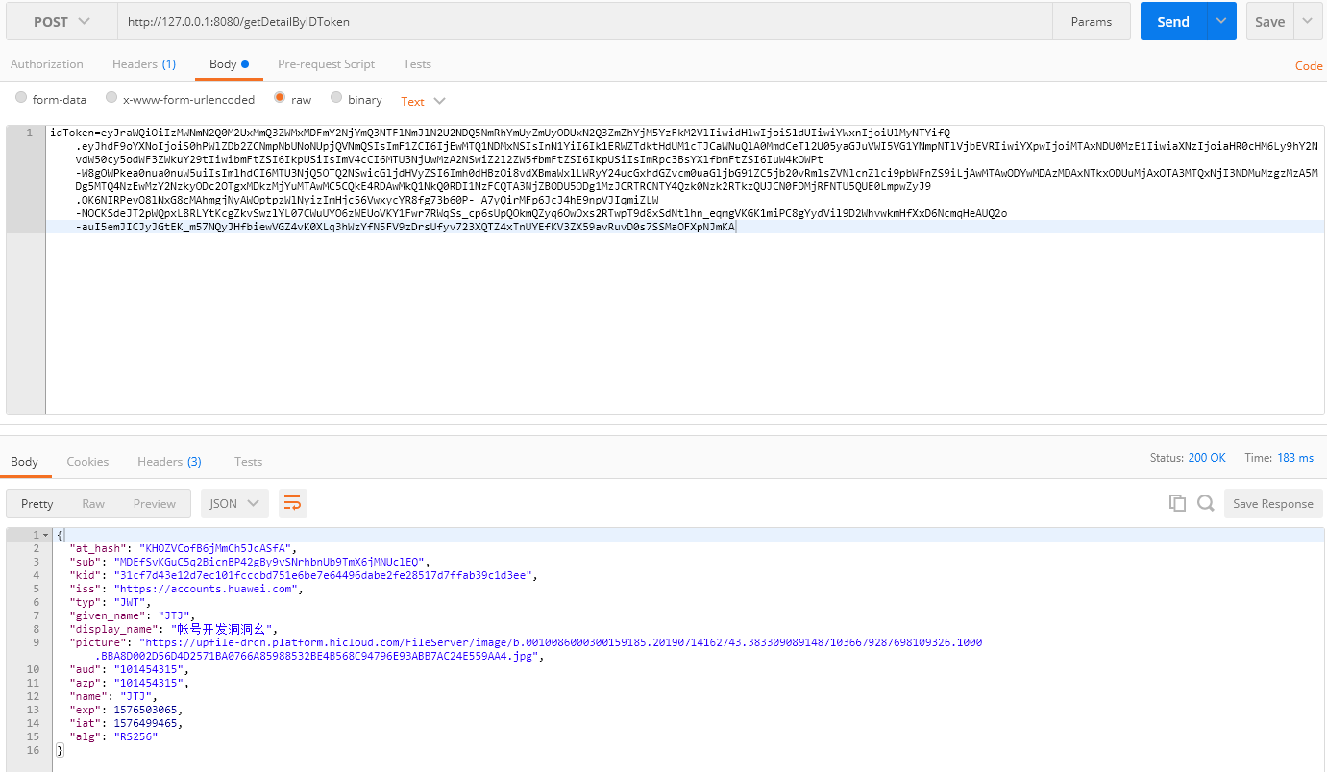

At this point, the example of APIs is done. Thank you.